**Understanding Elasticsearch with Catalog Index in Magento**

**Elasticsearch**

* Elasticsearch is a powerful search engine based on the Lucene library.
* It is used to store, search, and analyze large volumes of data quickly and in near real-time.
* In the context of Magento, it enhances the search capabilities of your online store.

**How Does Elasticsearch Work with Catalog Index?**

**1. Catalog Indexing Process**

**Indexing** is the process of converting data into a format that allows for fast search and retrieval. In Magento, the catalog index involves creating an Elasticsearch index that holds product data. Here’s how it works:

* **Data Sources**: Magento collects product information from the database, such as product names, descriptions, prices, and attributes.
* **Creating Index**: This data is then transformed into an Elasticsearch index. An index in Elasticsearch is similar to a database in SQL. Each index can contain multiple documents.
* **Documents**: Each product in your catalog is stored as a document in the Elasticsearch index. A document is a JSON object that contains all the relevant information about a product.

**2. How Data is Stored and Structured**

* **Mapping**: Before data is stored, Elasticsearch needs a mapping. Mapping defines how the documents and fields are stored and indexed. For example, it specifies the type of data for each field (text, keyword, date, etc.).
* **Field Types**: Common field types used in a product index include:
  + **Text**: Full-text fields that are analyzed and indexed.
  + **Keyword**: Non-analyzed fields used for exact matches (e.g., SKU).
  + **Numeric**: For prices and stock levels.

**3. Fetching Data**

When a user searches for products on the Magento store, the following happens:

* **Search Request**: A search request is sent to the Elasticsearch server. This request contains the user's search query.
* **Query Execution**: Elasticsearch processes the query against the indexed data. It uses its full-text search capabilities to find relevant documents based on the search terms.
* **Results**: Elasticsearch returns a list of matching documents (products) to Magento, which are then displayed to the user.

**4. Analyzers and Tokenizers**

* **Analyzers**: These are components that process text data during indexing and searching. They break text into tokens (words) and convert them into a format that can be searched.
* **Tokenizers**: A tokenizer is a part of an analyzer that splits the text into smaller parts. For example, it can separate words in a product name into individual tokens.

**Advantages of Using Elasticsearch with Magento**

1. **Speed**: Elasticsearch is designed for fast retrieval, making searches quicker compared to traditional databases.
2. **Scalability**: It can handle large volumes of data and search queries efficiently. You can scale your Elasticsearch cluster as your catalog grows.
3. **Advanced Search Features**: Supports complex queries, filtering, faceting, and suggestions. This enhances the search experience for users.
4. **Near Real-Time Search**: Updates to the catalog index can be reflected quickly, allowing users to see the latest products and inventory levels.
5. **Full-Text Search**: Elasticsearch excels in full-text search, providing more relevant results based on user queries.

**Disadvantages of Using Elasticsearch with Magento**

1. **Complex Setup**: Setting up and configuring Elasticsearch can be challenging for those unfamiliar with it. It requires some technical knowledge.
2. **Resource Intensive**: Elasticsearch can consume a lot of system resources (CPU and memory), especially with large data sets.
3. **Maintenance**: Regular maintenance is needed to keep the Elasticsearch cluster running smoothly, including managing indices and performing backups.
4. **Learning Curve**: Understanding the various features and configurations of Elasticsearch may require time and training.
5. **Dependency**: Your Magento store becomes dependent on Elasticsearch. If it goes down, the search functionality will be affected.

**Elasticsearch in the Magento Admin Panel**

1. **Configuring Elasticsearch**:
   1. Go to **Stores > Configuration > Catalog > Catalog > Catalog Search**.
   2. Set the **Search Engine** to **Elasticsearch** (or Elasticsearch 5+, Elasticsearch 6+, depending on your Magento version).
   3. Configure the **Elasticsearch Server Host** (usually localhost or the server where Elasticsearch is installed) and the **Elasticsearch Server Port** (default is 9200).
   4. Test the connection by clicking **Test Connection**.
   5. Save the configuration.

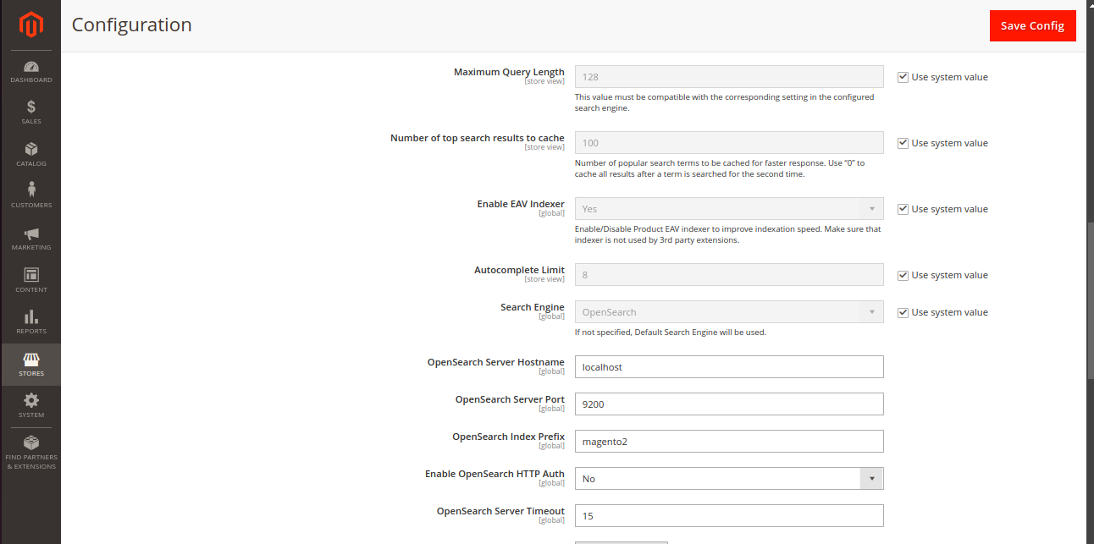

**In terminal activate elastic search and stop elastic search service commands and found status of elastic search**

sudo service elasticsearch start

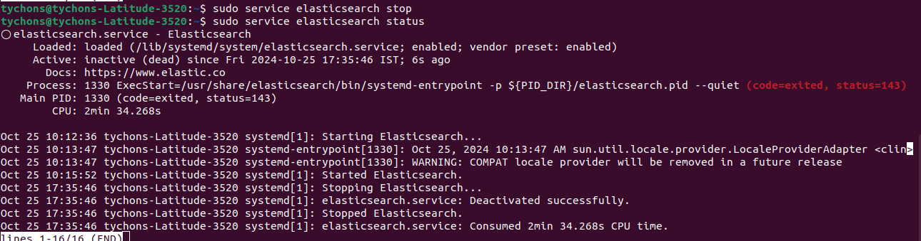

sudo service elasticsearch stop

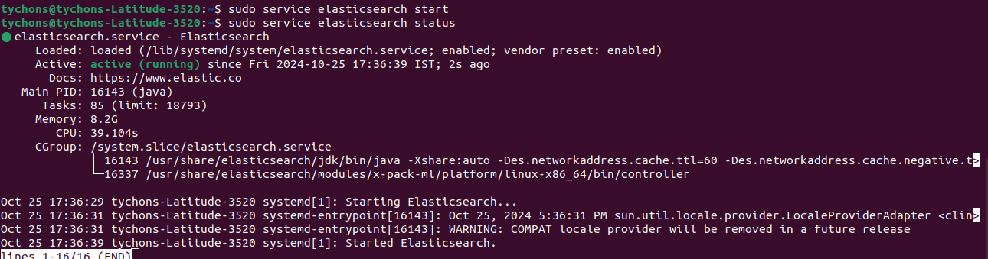

sudo service elasticsearch status

